Period | Topic | Learning objectives | Language | Practical methods | Text types | Evaluation
2 - 6  7 - 9  11 - 14 | Heroes | Define different types of heroes  Learn about real life heroes and heroes in literature  Learn grammar through the comic strip “Grammarman”  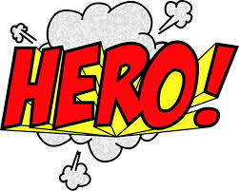 | Present simple  British and American English | Grammarman – online comic strips  Act out a script  Making a superhero illustration  Parts of the film “Robin Hood”  Think-pair-share  Venn-diagram | Comics  Factual text  Article  Novel extract | Writing: Hand in of mini presentation – “Creating a fictional superhero”  Speaking:  Mini presentation – “Creating a fictional superhero”  Presentation – “My hero”
 | Science and inventions | Explore famous inventions and inventors  Learn about teenagers and their brain and mindset  Learn basic first aid  Know and use graphs and charts presenting numbers  Explore new technology such as artificial intelligence | Verbs (past, present and imperative form)  Adjectives  Making new words by adding letters to its stem | Listen to an excerpt from Georges Marvellous Medicine  Simon Says  Make and read graphs and frequency tables  Watch clips of “the history of computers” | Factual texts  Articles  Poster  Graphs and charts  Novel extract | Writing:  E- mail – invitation to a scientist  Speaking:  Quest of the week – “A smart invention”.  
 | India    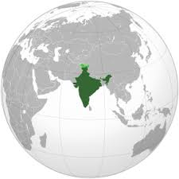 | Learn about India – culture, language, geography, the link between India and Britain, religion, traditions, food, sports, attractions, technology, well known leaders and authors.  Get to know Mahatma Gandhi and his peaceful work towards an independent India  Read extracts from a few of Rudyard Kiplings stories (The Jungle Book, Just so stories – “How the leopard git his spots” and “How the camel got his hump”) | Concord  Verbs (all tenses)  Question words | Practical exercise using sticky notes to range countries from largest to smallest (area and population)  Story in an envelope  Group relay race  Making a poster  Make a “Guess what” list with facts from Norway  Watch parts of “Mowgli”  Comparison of India and Britain using a grid | Factual text  Novel extract  Comic strip  List  Film  Article | Writing and speaking:  Poster for the classroom wall  (places or people)  Speaking:  Conversations in small groups – “A visitor from Norway”
15 | Language week | Practical activities to strengthen English in authentic situations |  |  |  | 
17 - 18 | 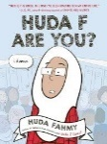  Graphic novel | Read the novel “Huda F are you?” by Huda Fahmy  Conversations about identity and culture  Learn about the graphic novel genre and essential comic strip key words | Literary devices | Create a comic strip on a situation where one felt different or had to explain who they were | Graphic novel (comic strips) | Writing:  Create a comic strip
19 - 20 | Preparations for end term test | Read texts from the preparation material and work with their content  Repeat writing structures and practise writing paragraphs on the topic | Individually from the feedback each student has been given | 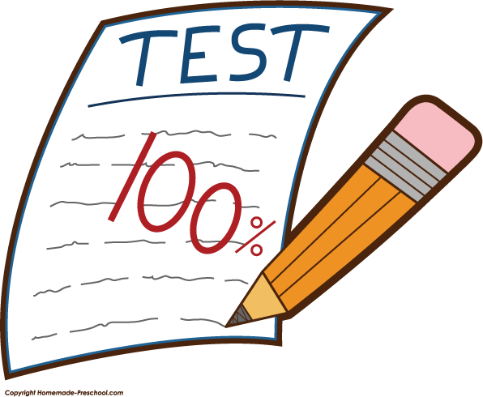 |  | Written: End term test  Part 1 – Listening and Reading  Part 2 – Conveying Content  Part 3 – Interaction  Part 4 – Written Production
21 - 25 | Forces of nature and personal disasters  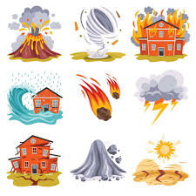 | Do research on and work with natural disasters, like hurricanes, floods, tsunamis, earthquakes, blizzards, volcanic eruptions and avalanches.  Learn about preventive measures, how societies work together, and consequences.  Explore both minor personal issues and major ones | Contractions  Adjectives (comparative and superlative form)  AM and PM | Watch a documentary  Think-pair-share  Memory  Music  Practice first aid  Make a timeline | Diary extract  Factual texts  Novel extracts  Article | Writing:  Write a story, eyewitness account or blog post.  Speaking:  In pairs - make a television broadcast (news reporter and eyewitness)

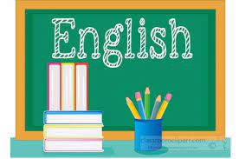
Relevance and central values: https://www.udir.no/lk20/eng01-04/om-faget/fagets-relevans-og-verdier
Interdisciplinary topics: https://www.udir.no/lk20/eng01-04/om-faget/tverrfaglige-temaer?lang=nob
Core elements: https://www.udir.no/lk20/eng01-04/om-faget/kjerneelementer
Basic skills: https://www.udir.no/lk20/eng01-04/om-faget/grunnleggende-ferdigheter

